Name: ________________________________________ Arr: _________

Chapter 20 Written Problems INTERMEDIATE

**Use this sheet to record your answers to the following Chapter 20 Challenge Problems.**

1. Bill points his infrared 2Y0A21 sensor at an object and the sensor returns a value of 829. Suzi points her 2Y0A21 sensor at the same object and her sensor returns a value of 250. Whose sensor is closer to the object? Can you be certain?
2. Josie points her infrared 2Y0A21 sensor at an object and claims her sensor consistently returns values near 300. Ivy points her 2Y0A21 sensor at another object and claims her sensor consistently returns values near 1200. Which one of them is not telling the truth, and how do you know?
3. 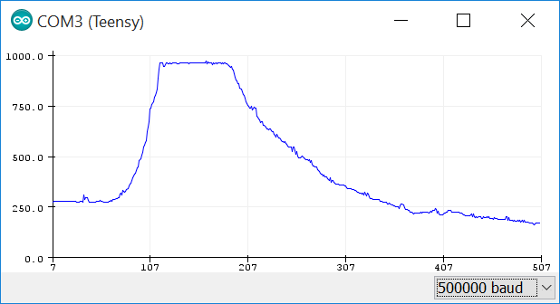The figure at the right shows raw digital data recorded by a 2Y0A21 sensor. The sensor was attached to the front of the OneBot and aimed so its infrared beam was parallel to the ground. The autonomous robot was turned on and placed on the floor. Write a brief but descriptive narrative relating the events that might have created such a graph.
4. Study the following algorithm and find the **one mistake** in the code. Assume that a brand new 2Y0A21 infrared sensor is connected to pin 12 on the PRT3 and is powered with 5V. The sketch compiles and uploads just fine, and data is printed to the screen. However, the sensor does not respond appropriately when a solid object is placed within its infrared beam. That is, the data on the Serial Monitor seems to be random no matter how near or how far the object is from the sensor. What is the mistake in the code?

const byte IRPin = 12; // select the input pin for your sensor

void setup() {

pinMode(IRPin, INPUT); // NOT necessary but OK for continuity

}

void loop() {

int sensor = analogRead(IRPin); // grab a sensor reading

Serial.println(sensor); // print the sensor reading

delay(150);

}

1. Study the following algorithm and find the **one mistake** in the code. Assume that a brand new 2Y0A21 infrared sensor is connected to pin A6 on the PRT3 and is powered with 5V. The sketch compiles and uploads just fine, and data is printed to the screen. However, the sensor does not respond appropriately when a solid object is placed within its infrared beam. That is, the data on the Serial Monitor seems to have no bearing on how near or how far the object is from the sensor. What is the mistake in the code?

const byte IRPin = A6; // select the input pin for your sensor

void setup() {

pinMode(IRPin, OUTPUT);

}

void loop() {

int sensor = analogRead(IRPin); // grab a sensor reading

Serial.println(sensor); // print the sensor reading

delay(150);

}

1. Study the following algorithm and find the **one mistake** in the code. Assume that a brand new 2Y0A21 infrared sensor is connected to pin A6 on the PRT3 and is powered with 5V. The sketch compiles and uploads just fine, but, as shown in the figure below, the only data that prints to the screen is the number 20 no matter how near or how far an object is from the sensor. What is the mistake in the code?

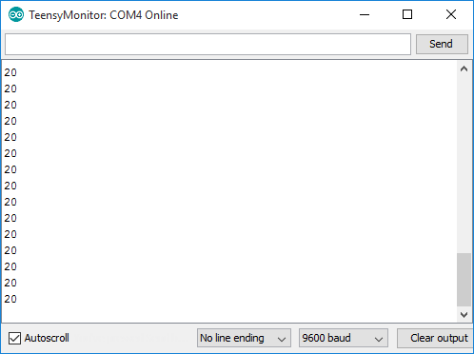

const byte IRPin = A6;

void setup() {

pinMode(IRPin, INPUT);

}

void loop() {

int sensor = analogRead(IRPin);

Serial.println(IRPin);

delay(150);

}

1. Study the following algorithm and write down all possible outcomes. Do **not** run this code with your microcontroller – instead simply *predict* all possible outputs of the algorithm. Assume that a 2Y0A21 infrared sensor is connected to analog pin A6 on the PRT3.

**Output:**

void P8(){

int IR = analogRead(A6);

if (IR > 1500) {

Serial.println ("Result A");

}

else {

Serial.println ("Result B");

}

}

1. Study the following algorithm and write down all possible outcomes. Do **not** run this code with your microcontroller – instead simply *predict* all possible outputs of the algorithm for analogRead() values of 200, 400, 600, and 800. Assume that a 2Y0A21 infrared sensor is connected to analog pin A6 on the PRT3.

void P9(){

**Output for these** analogRead() **values:**

* **200: _______________**
* **400: _______________**
* **600: _______________**
* **800: _______________**

int IR = analogRead(A6);

if ( (IR < 250) && (IR > 760) ){

Serial.println ("Result A");

}

else if (IR > 700) {

Serial.println ("Result B");

}

else {

Serial.println ("Result C");

}

}

1. Study the following algorithm and write down all possible outcomes. Do **not** run this code with your microcontroller – instead simply *predict* all possible outputs of the algorithm for analogRead() values of 200, 400, 600, and 800. Assume that a 2Y0A21 infrared sensor is connected to analog pin A6 on the PRT3.

void P10(){

**Output for these** analogRead() **values:**

* 200: _______________
* 400: _______________
* 600: _______________
* 800: _______________

int IR = analogRead(A6);

if (IR <= 1023) {

Serial.println ("Result A");

}

else if (IR < 500) {

Serial.println ("Result B");

}

else if (IR < 200) {

Serial.println ("Result C");

}

else {

Serial.println ("Result D");

}

}

1. Study the following algorithm and write down all possible outcomes. Do **not** run this code with your microcontroller – instead simply *predict* all possible outputs of the algorithm for analogRead() values of 200, 400, 600, and 800. Assume that a 2Y0A21 infrared sensor is connected to analog pin A6 on the PRT3.

void P11(){

**Output for these** analogRead() **values:**

* **200: _______________**
* **400: _______________**
* **600: _______________**
* **800: _______________**

int IR = analogRead(A6);

if (IR >= 1023) {

Serial.println ("Result A");

}

else if (IR > 500) {

Serial.println ("Result B");

}

else if (IR > 200) {

Serial.println ("Result C");

}

else {

Serial.println ("Result D");

}

}

1. Use Equation 20.1 on page 772 to calculate the digital IR value that should be returned by the Sharp 2Y0A21 infrared sensor if an object is 13cm away. What about 33cm? 51cm? Can you determine the output for an object 3cm away? What about 125cm?

**Sharp 2YOA21 digital values for these distances:**

* **13cm: _______________**
* **33cm: _______________**
* **51cm: _______________**
* **3cm: ____________________________________________________________________**
* **125cm: __________________________________________________________________**

Turn in this sheet to be graded.